SUMMER TRAINING PORTFOLIO: ETHICAL HACKING

- Title: Summer Training Portfolio on Ethical Hacking
- Name: Mowa Dacgne Danielle
- Student ID: 2424441
- Email: mowadanielle22@gmail.com
- Course/Branch: BSC. Cybersecurity, 4th semester
- Institution: Chandigarh School of Business (CSB)
- Training duration: 08/06/2026 - 06/07/2026
(4 weeks)

Introduction:
Ethical hacking is the authorized practice of testing computer systems, networks, and applications to identify security vulnerabilities before malicious attackers can exploit them.

The purpose of ethical hacking training is to equip individuals with the skills to test systems for vulnerabilities and secure them against threats using the same tools and techniques as malicious hackers, but with explicit authorization.

This training aims to help organizations identify security weaknesses before they can be exploited, thereby preventing cyberattacks and protecting sensitive data.

What are you expected to learn?
Ethical training expects you to master networking fundamentals (Protocols, DNS...), Linux proficiency (kali linux), Windows iso, cybersecurity tools and operate within defined scopes and obtain proper authorization.
You will also develop critical soft skills, including analytical problem-solving, hacker psychology to anticipate adversary behaviour, and executive reporting to effectively communicate risks and remediation strategies to non-technical stakeholders

Training objectives:
- Understand networking fundamentals.
- Learn cybersecurity concepts.
- Understand the different phases of ethical hacking
- Set up safe virtual laboratories.
- Use cybersecurity tools.
- Perform vulnerability assessments.
- Analyse network traffic.
- Learn ethical practices.

Weekly Summary
Week 1:
Footprinting and Reconnaissance

Footprinting Concepts:
Footprinting is the initial phase of ethical hacking where security professionals systematically gather information about a target system, network, or organization to identify potential vulnerabilities and attack vectors.
The primary goal is to map the target’s digital footprint, including IP addresses, domain names, operating systems, and network topology, without directly interacting with the infrastructure in a way that causes disruption.
Some footprinting tools include:
- WHOIS
- nslookup
- dig
- theHarvester
- Maltego
- Recon-ng

Reconnaissance:
Reconnaissance is the initial phase of ethical hacking where hackers gather information about a target system, network, or organization to understand its attack surface and identify potential vulnerabilities.
This process is divided into two more categories namely:
- Passive Reconnaissance: Involves gathering information without directly interacting with the target system, making it stealthy and less likely to be detected.
- Active Reconnaissance: Involves direct interaction with the target system to obtain more precise and up-to-date intelligence.

Network Scanning
Network scanning in ethical hacking is the systematic process of sending specially crafted packets to a network to identify live hosts, open ports, and running services, thereby mapping the target environment and uncovering potential vulnerabilities

Scanning tools
Scanning tools are software utilities used during the active reconnaissance phase to identify live hosts, open ports, running services, and known vulnerabilities within a target network.

They include:
- Nmap (Network Mapper)
- Nessus
- OpenVAS
- Wireshark
- Masscan

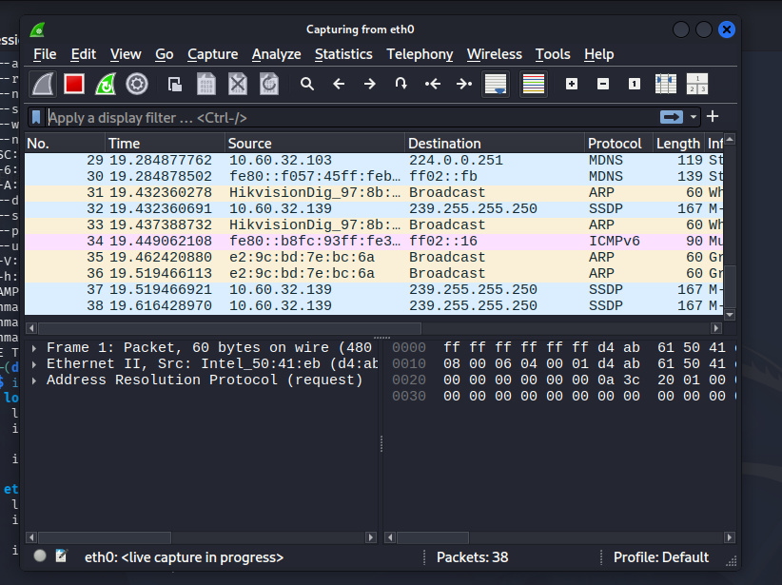
~ Wireshark used for network scanning in Kali Linux

Enumeration
Enumeration in ethical hacking is the active process of systematically probing a target system or network to extract detailed, structured information such as valid usernames, machine names, open ports, running services, and network shares.
Unlike passive reconnaissance, this phase involves direct interaction with the target to convert raw scanning data into actionable intelligence that reveals potential vulnerabilities and entry points for exploitation.

LDAP Enumeration
LDAP enumeration is the process of actively querying Lightweight Directory Access Protocol (LDAP) servers to extract sensitive information such as usernames, group memberships, organizational structures, and network resources

Vulnerability Assessment
Vulnerability assessment in ethical hacking is a systematic process of identifying, classifying, and prioritizing security weaknesses in a system or network before they can be exploited by malicious actors.
This approach allows ethical hackers to help organizations mitigate risks and improve defences without causing harm, serving as a critical component of a comprehensive cybersecurity strategy.
Week 2:

System Hacking
System hacking is the methodical process of exploiting vulnerabilities in computer systems, networks, or software to gain unauthorized access and control over digital assets.
It involves using technical skills to manipulate system behaviour in ways designers did not intend, ranging from simple password guessing to sophisticated exploits like buffer overflows or SQL injection.

Password Cracking
Password cracking is the process of recovering or guessing passwords from stored or transmitted data, typically hashed cryptographic values, to gain unauthorized access to systems or accounts.
While legitimate security professionals use these techniques to identify weak passwords, cybercriminals exploit them to steal data, conduct espionage, or launch further attacks.
Methods used in password cracking:
- Brute force
- Dictionary attack
- Hybrid attack…

Malware Concepts
Malware (short for malicious software) is any software intentionally designed to disrupt, damage, steal data from, or gain unauthorized access to a computer system, network, or device.
There exist different types of malwares:
- Viruses and Worms: Self-replicating programs that spread across networks.
- Trojans: Malware disguised as legitimate software to gain unauthorized access.
- Ransomware: Software that encrypts files and demands payment for release.
- Spyware and Keyloggers: Tools designed to steal sensitive information and keystrokes.
- Rootkits and Bootkits: Advanced malware that hides deep within the operating system.
- Adware: (short for advertising-supported software) is software that displays unwanted advertisements on a user's device, often to generate revenue for its creators.

Sniffing concepts
Sniffing is the process of intercepting, monitoring, and analysing data packets as they travel across a network. It is analogous to eavesdropping on a conversation, allowing the observer to decode protocols and examine packet headers and payloads to extract information such as source addresses, content, and sensitive credentials.
The practice is categorized into two main types:
- Passive Sniffing: Involves simply listening to network traffic without injecting any packets. This is typically used on networks using hubs, which broadcast all traffic to connected devices.
- Active Sniffing: A more aggressive technique that involves injecting packets (such as ARP requests) into the network to flood switch tables, tricking the network into sending all traffic to the attacker's machine. This is commonly used on switched networks.

Social Engineering
Social engineering in ethical hacking is the authorized, legal practice of manipulating human psychology to test an organization's security posture and identify vulnerabilities in the "human firewall."
Unlike malicious attacks, this technique is conducted with explicit permission to simulate real-world threats such as:
- Phishing
- Pretexting
- Baiting
- Tailgating
- Whaling
- Business Email Compromise (BEC)
Helping organizations strengthen their defences through employee training and improved security protocol.
Week 3:

DoS Attack
A Denial-of-Service (DoS) attack is a cyberattack where a perpetrator seeks to make a machine or network resource unavailable to its intended users by temporarily or indefinitely disrupting services.
This is typically accomplished by flooding the targeted machine or resource with superfluous requests in an attempt to overload systems and prevent legitimate requests from being fulfilled.

DDoS Attack
A Distributed Denial-of-Service (DDoS) attack is a malicious attempt to disrupt the normal traffic of a targeted server, service, or network by overwhelming it with a flood of internet traffic.
- Unlike a standard Denial-of-Service (DoS) attack, which originates from a single source, a DDoS attack leverages multiple compromised computer systems, often forming a botnet of infected devices like IoT gadgets, computers, and servers.
- This distributed approach allows attackers to generate exponentially more traffic, making the attack harder to trace and defend against.

Session Hijacking
Session hijacking is a cyberattack where an adversary steals or manipulates a valid session token (such as a cookie) to gain unauthorized access to a user’s active account, effectively impersonating them without needing their password.
Attackers typically acquire these tokens through methods including packet sniffing on unsecured networks, Cross-Site Scripting (XSS) vulnerabilities that inject malicious scripts to steal cookies, or Man-in-the-Middle (MITM) attacks that intercept communication between the client and server.
- BURPSUITE TOOL

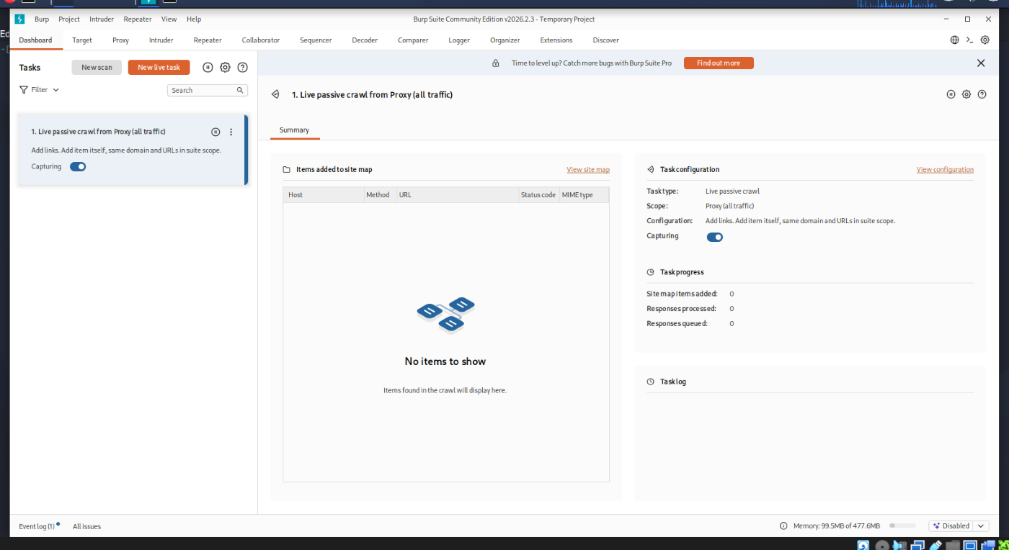

Week 4:
IDS, IPS, Firewall and Honeypot Concepts

IDS (Intrusion Detection System)
IDS is a cybersecurity technology that monitors network traffic or system activity for suspicious behaviour, malicious activity, or policy violations.
It acts as a passive security tool, functioning like a digital security camera that analyses data packets to identify potential threats such as unauthorized access, malware, or anomalies.
Key types include:
- Network IDS (NIDS): Monitors traffic across an entire network subnet, typically deployed behind firewalls.
- Host-based IDS (HIDS): Installed on individual devices to monitor internal state, files, and logs.

IPS (Intrusion Prevention System)
IPS is a network security tool that continuously monitors network traffic for malicious activity and automatically blocks detected threats in real time.
- Unlike intrusion detection systems (IDS) which only alert administrators, an IPS is deployed in line with network traffic, allowing it to take immediate action such as dropping malicious packets, blocking specific IP addresses, or terminating dangerous connections.

Firewall
A firewall is a network security system that monitors and controls incoming and outgoing network traffic based on predetermined security rules.
It acts as a barrier between a trusted internal network and an untrusted external network (such as the Internet) to prevent unauthorized access and cyberattacks. Different types exist:
- Packet-filtering firewall
- Nex-generation firewall
- Host-based firewall
- Stateful firewall
- Web application firewall

Honeypot
A honeypot is a decoy system, network, or service designed to mimic legitimate digital assets to lure cyber attackers away from real, sensitive infrastructure.
By intentionally appearing vulnerable, it attracts malicious traffic, allowing security teams to detect, study, and analyse attacker behaviour, tools, and tactics without risking production environments.

Web Server Concepts
A web server is a combination of hardware and software that stores, processes, and delivers web content (such as HTML pages, images, and videos) to users over the internet via the HTTP or HTTPS protocols.
When a user enters a URL into a browser, the browser sends a request to the web server, which retrieves the requested files and sends them back as a response.
Basic Components of a Web server:
- Hardware: The physical computer or virtual machine that provides processing power, memory, and storage for website files.
- Software: Programs like Apache, Nginx, or Microsoft IIS that listen for incoming requests, manage traffic, and serve the appropriate content to the client.
- Protocols: HTTP/1.1, HTTP/2, HTTP/3 (QUIC- Quick UDP Internet Connections), TLS/SSL for encryption

SQL Injection
SQL injection is a cyberattack where malicious SQL (Structured Query Language) statements are inserted into backend database fields. It happens when a website or application improperly handles user input, allowing attackers to manipulate database queries to steal, alter, or delete sensitive data.
Some SQL injection tools: Burpsuite, sqlmap, BBQSSQL, NoSQLMap

Common Attack Methods:
- Data Theft: Retrieving private customer records, passwords, or intellectual property from the database.
- Data Manipulation: Modifying database contents, such as changing transaction balances or account details.
- Data Deletion: Dropping entire database tables, causing massive service outages.
- Authentication Bypass: Gaining administrative privileges or sneaking into restricted accounts without valid credentials.

Web Application Attacks
Web application attacks are malicious attempts to exploit vulnerabilities in software, APIs, and web services. Threat actors target these flaws to disrupt business operations, steal sensitive data, or compromise backend systems.
Top vectors and Techniques:
Injection Attacks (e.g., SQLi, NoSQLi): Malicious inputs or commands are injected into application fields (e.g., login forms, search bars) to trick the backend database into executing unauthorized queries or exposing restricted data.
Broken Access Control: Failures in restricting what authenticated users can do. Attackers manipulate parameters to bypass permissions or access unauthorized functionality and data (such as Insecure Direct Object References, or IDOR).
Cross-Site Scripting (XSS): Threat actors inject malicious, executable scripts into otherwise trusted websites. When other users view the page, the script executes in their browser, potentially stealing session tokens or cookies.
Authentication & Session Attacks: Exploits like credential stuffing and brute-force attacks allow hackers to take over legitimate user accounts or bypass login portals.

Practical activities: DONE USING THE KALI LINUX AND WINDOWS VIRTUAL MACHINES
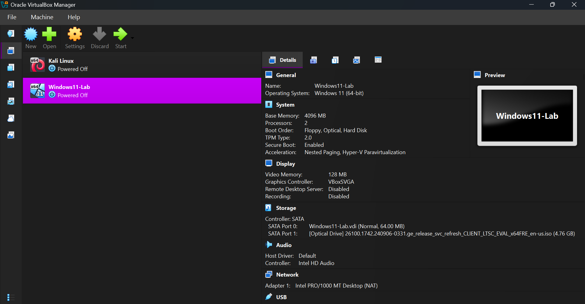

Skills Acquired:

Technical skills:
- Basic Linux commands
- Networking concepts
- Packet analysis
- Vulnerability assessment
- Virtualization

Professional skills:
- Problem solving
- Documentation
- Ethical decision making

~ Challenges Encountered:
  - Installing Kali Linux
  - Configuring VirtualBox
  - Understanding networking protocols and network security tools

~ How I overcame these Challenges:

- Installing Kali Linux: I encountered installation errors initially, but by following the recommended installation steps and troubleshooting the VM configuration, I was able to complete the installation successfully.

- Configuring VirtualBox: I experimented with different VirtualBox settings, referred to the course material, and successfully configured the virtual machines for the required networking setup.

- Understanding networking protocols and network security tools: I improved my understanding by combining theoretical study with practical exercises, making it easier to relate concepts such as TCP/IP, ARP, and DHCP to real network traffic and the different tools along with their purpose.

Conclusion:

The practical sessions were initially challenging because I had little prior experience with Kali Linux, VirtualBox, and cybersecurity tools. Understanding the different Linux commands, networking concepts, and the operation of security tools required time and continuous practice. Although I did not memorize every command used during the training, I gradually became familiar with several important commands and gained a better understanding of their purpose. Through repeated hands-on exercises and guidance from the instructors, I developed confidence in navigating the Linux environment and applying fundamental cybersecurity concepts.
This experience motivated me to continue practicing and improving my technical skills beyond the training.

